Wigan Wheelers and Triathlon Club - Open 30 Miles TT L308
Sunday 22nd AUGUST 2021 - START SHEET
PLEASE READ ALL THE RACE DETAILS CAREFULLY
If you are a UNDER 18 Competitor – please ask your parent / guardian to also read this, thank you
Promoted on behalf of Cycling Time Trials under their rules and regulations
** Please note due to the ongoing COVID-19 Pandemic CTT have completed an additional risk assessment on how events can be conducted. Please note this event will work differently from previously and it is vitally important you read the COVID-19 guidance in the document below. If more updates come into effect from CTT prior to the event starting I will inform you via email as soon as possible or on the day of the event.
Failure to abide by the COVID-19 risk assessment could result in suspension of CTT activities and issues with local authorities around specific courses. We ask therefore for the ongoing prosperity of the sport you follow the guidelines to the letter.
Local Lockdown regulations can result in the race being cancelled at short notice or new rules and regulations to follow.
Event Secretary: Nigel Clementson - 07862289430 Time Keepers: Amanda Asbridge
Headquarters: Sizergh, Nr Kendal, LA8 8DZ (Lay-By). There are no toilet facilities available
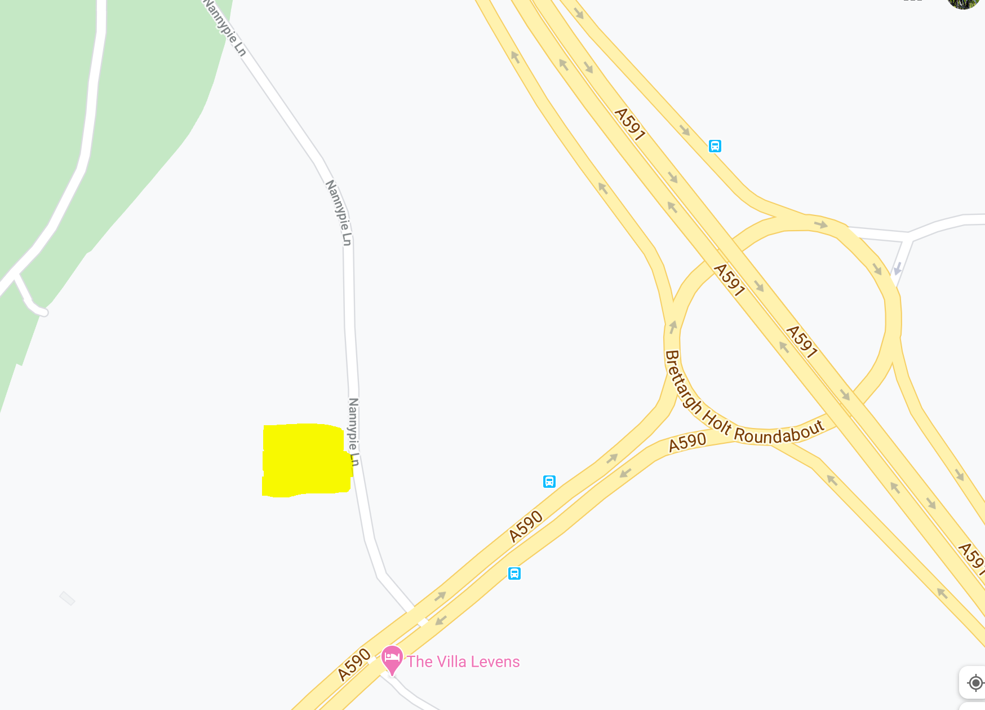
HQ opens from 07.00 First rider off 08.26
Please allow 15 minutes to ride to the start.
Remember the start is on the opposite side of the road to the 10. DO NOT CROSS OVER THE DUAL CARRIAGE.
Do not arrive more than 5 mins before your start time. From the HQ- follow the road back to the A590, turn left to the RAB encircle and ride back up the A590 Take the first slip road A6 Milnthorpe. At the T junction turn right go under the A590 and take the right slip road back onto the A590 to the START.
(DO NOT PASS THE START YOU WILL BE DISQUALIFIED)
We will be keeping in place some regulations from last year, even though CTT COVID-19 Risk Assessment has been amended to allow back some normality. There will be NO results board displayed at HQ and complete results will only be available via the CTT website post event after verification from the timekeeper. Provisional results will be available via the clubs facebook page on the night - https://www.facebook.com/WWCCWTC
CTT Regulation 17: Signing-on & signing-out sheet
- The competitors in all types of events must make themselves aware of any special instructions for the event and sign the official signing on sheet when collecting their number.
- In type A events a competitor must return to the HQ either during the event or within a reasonable time after the last rider has finished the event and sign the official signing out sheet.
NEW MEASURES IN PLACE - please BRING YOUR OWN PEN AND MASK. Numbers will be available at the sign in / out desk and to be placed in a soapy solution bucket when you sign out. Please BRING YOUR OWN PINS. If you would like to use your own number this is fine, so long as it is approved CTT yellow number – put please remember to sign in and sign out.
There will be a copy of the risk assessment for viewing. This will also be on the clubs website: www.wiganwheelers.org

Course: L308 - description
This event is being run on the L308 course.
START at north east end of layby on A590 approximately 0.7 miles south west of roundabout junction of A590 and A591. Proceed north east to encircle roundabout (0.65m) and retrace along A590 to Meathop roundabout (6.68m). Take the first exit on the B5277 towards Lindale, where encircle the mini roundabout (7.97m) and retrace along the B5277 to Meathop roundabout (9.26m). Take the second exit and proceed north east along the A590 past the start to complete 1 lap (14.66m). Proceed again via A590/A591 roundabout and Meathop/Lindale roundabouts to complete a second lap (29.32m) After passing the start for a second time proceed a third time to Roundabout junction with A590/A591 (29.96m), where take the second exit onto unclassified road (Nannypie lane) to finish at ‘Clearway end’ signs on bend just before layby on left (30m).

The following Local Regulations have been approved by the National Committee in accordance with
Regulation 38. Any breaches may lead to disciplinary action being taken.

Local Reg No. 5 In all events, competitors prior to starting are not permitted to ride past the finishing timekeeper during the duration of the event.
Local Reg No.6 Any competitors making a U turn in the vicinity of the start or finish will be disqualified from the event.
Local Reg No.10 Course L308-warming up on the course is not permitted during the duration of the event.
Local Reg No. 12 – NO PARKING on the car park or on the frontage of the Strickland Arms.
Local Reg No.15 Riders must keep to the left hand side of the road except when overtaking. Failure to comply with the above may lead to disqualification. Riders must give their number at the finish and elsewhere on the course where requested.
IN ADDITION TO THE ABOVE
Riders must give their number at the finish and elsewhere on the course if requested.
Riders MUST NOT STAND in the road at the start or finish. (This constitutes obstruction and is a breach of regulations and breaches the COVID-19 risk assessment below.)
Riders must NOT ride with their heads down.
Rider Safety Helmets: All competitors under the age of 18 and/or juniors must wear a HELMET of HARD/SOFT SHELL construction that conforms to a recognised Standard (See Regulation 15). Cycling Time Trials strongly recommends ALL competitors to wear such a helmet.
Competitor Machines - Lights: CTT Regulation 14(i) – Compulsory Use of Rear Red Light
NO WORKING REAR RED LIGHT – NO START.

Prize List
Prize | Men |  | Women
1st | 30 |  | 30
2nd | 25
3rd | 20
4th | 15

Fastest team of 3 - £12 each (One rider one prize apart from team prize)
Please note there will be no prize presentation at the event due to the clubs COVID-19 Risk assessment. Once we have finalised results we will reach out to you to arrange payment of prize money.

COVID – 19 Risk Assessment - IMPORTANT - READ CAREFULLY
General / Before the Event
- Only attend the event if you are in good health. If you are experiencing any symptoms associated with COVID-19 you must not attend
- Competitors should arrive ‘dressed to race’
- For the Junior and Juveniles that are racing - members of your household should attend with you. They also need to follow the guidelines stated in this briefing. Please ask them to wear a mask in the signing on/out area. They can assist you with mechanicals and first aid issues. They cannot sign on/out for you, but should be present when you do so.
At HQ
- Competitors MUST NOT gather in anyway regardless of current guidelines in the car park, HQ area or elsewhere.
- No refreshments will be served at HQ
- Please ONLY park front bumper to rear bumper to encourage social distancing. Parking is available along the road with the layby. Please ensure you park respectfully and legally.

- Please remain at your car unless preparing to ride your bike, signing in or out.
- Turbos will be permitted at the rear of your vehicle in the HQ Lane - nannypie Lane. Turbo training warm up elsewhere is permitted so long as you park legally and away from a residential area. See below for further areas to park in the area.
- Please bring your own pen and mask to the event to sign on.
- On arrival please come to HQ, The start sheet will be displayed on the table and the numbers laid out. Please sign on using your pen, take your number and return to your vehicle.
- Toilet facilities will be unavailable at the HQ as the required cleansing of these facilities could not be maintained.
- We encourage riders to warm up on the road. See below for further areas to park in the area.
During The Race
- An elevated resting heart rate or exceptionally quick to react heart rate during warm up can suggest an underlying asymptomatic illness of ANY kind. You should NOT start the event (DNS) and leave immediately. Do not go to the start line if you feel this is the case and notify the organiser of your intention not to start as a result of an adverse warmup after the event via telephone.
- Competitors MUST NOT leave any personal items with the time keeper or at the signing on/out table.
- There will be no pusher-off.
- Competitors must start with one foot on the ground.
- The timekeeper will be parked at the start line. They will either be at least 2 metres out of their vehicle or they will tap on the window to get the riders attention and count down to zero on their fingers to signal the competitor to start.
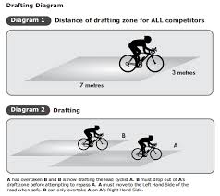
- Please arrive at the start no more than 5 minutes before your allocated start time and ensure that you line up more than two meters apart from other competitors. 2 Meters will be signalled in the layby by chalk or an alternative method.
- Spectators should ideally not attend unless supporting the running of the event.
- Drafting - If you should catch up another rider you should try to pass as quickly as possible and must not in any other circumstances ride close behind so that you take shelter from the wind. You must set your own pace and not use another rider as a pace maker. The onus on avoiding company riding shall be on the rider overtaken. Nor is it in order to ride alongside and even to ride a few metres behind for any appreciable distance. In the spirit of the sport, caught riders should not disturb the performance of the rider catching them by re-passing and/or riding closely behind them, except when they can sustain that move. This is generally considered to mean that the caught rider should allow a reasonable gap to develop of some 30 to 50 yards/metres.
- No support can be provided if a competitor suffers mechanical difficulties. It is strongly advised that all competitors carry with them a spare inner-tube/tubular, pump and tyre levers if required.
- Support vehicles are only permitted to pass you once within 10 miles and should not follow you on the course - this is probably mainly for the Junior and Youth rider who are permitted 1 member of their household with them. Riders should also have a first aid kit in their vehicle. In an emergency marshalls will contact Amanda Asbridge to deal with the situation who will assess the situation and seek emergency help if required. Full PPE available if needed in an emergency. It is at the discretion of the marshals if they would like to assist. They may ring the emergency services instead.
- It is strongly advised that all competitors carry a mobile phone (left in your vehicle whilst racing out of sight) and take with them the telephone number of the event organiser - Amanda Asbridge 07720060021. Please telephone the organiser if you have failed to finish the event.
After the Race
- Competitors on finishing MUST NOT stop at the finish and MUST NOT loiter at the HQ/car park and MUST pack away and leave immediately upon completion of the race.
- No Results board or prize giving will be conducted on the day to ensure people do not gather at HQ. Results will be available via CTT and sent via e-mail as soon as we have collated them after the event. The event organiser is away for a couple of days after the event, so there maybe a delay in final results being updated on CTT.
This event may be subject to a Doping Control
It is your responsibility to check As soon as you have finished you should return to the event HQ as it is your responsibility to check if you are required for Doping Control Race numbers required for Doping Control will be displayed at the HQ adjacent to the result board If your number is displayed you should report immediately to Doping Control which will be nearby Remember, it is up to you to check and ensure that you comply If required you must report to Doping Control after finishing without delay
Additional places to park

LA8 8EA
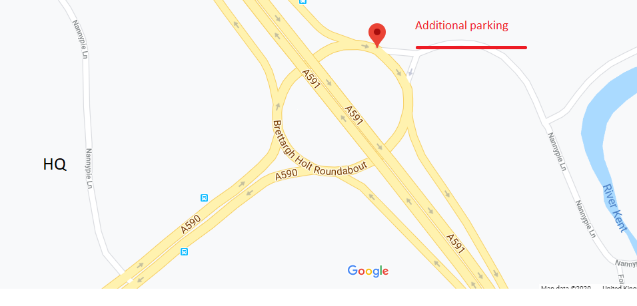

LA8 8EG
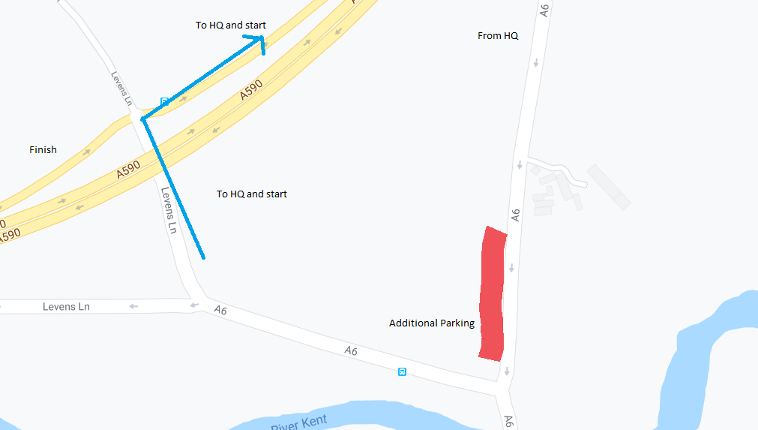

There are smaller laybys on the course A590 and the A6 and Nannypie Lane.
Please be considerate when parking and social distance at all times. Do not get changed, urinate or warm up in front of or in close proximity of any residential home.
Safe Ride and best of luck from the Wigan Wheelers
Nigel Clementson

